Superior University Gold Campus
Lab Task 3
Artificial Intelligence Lab
Name: Tasawar Hussain
Roll no: SU92-BSSEM-F24-073
1. Objective & Introduction
The objective of this lab is to formulate state-space problems and apply uninformed search algorithms—including Breadth-First Search (BFS), Depth-First Search (DFS), Depth-Limited Search (DLS), Iterative Deepening DFS (IDDFS), and Uniform Cost Search (UCS)—on problem graphs. We analyze their expansion order, returned paths, completeness, optimality, and time/space complexities.
2. Task 1: Manual Traces of BFS and DFS
Graph Topology
- Nodes & Successors:
  - $A→\left[B,C\right]$
  - $B→\left[D,E\right]$
  - $C→\left[F\right]$
  - $D→\left[\right]$, $E→\left[G\right]$, $F→\left[\right]$, $G→\left[\right]$
- Start State: $A$ | Goal State: $G$
BFS Frontier & Visit Trace
- Mechanism: First-In, First-Out (FIFO) queue. Level-by-level expansion.
- Execution Trace:
  - Pop $A$ $→$ Queue: $\left[B,C\right]$
  - Pop $B$ $→$ Queue: $\left[C,D,E\right]$
  - Pop $C$ $→$ Queue: $\left[D,E,F\right]$
  - Pop $D$ $→$ Queue: $\left[E,F\right]$
  - Pop $E$ $→$ Queue: $\left[F,G\right]$
  - Pop $F$ $→$ Queue: $\left[G\right]$
  - Pop $G$ $→$ Goal Reached!
- Visit Order: $A→B→C→D→E→F→G$
- Final Path: $A→B→E→G$ (Depth 3)
DFS Frontier & Visit Trace
- Mechanism: Last-In, First-Out (LIFO) stack. Reverses neighbor insertion so leftmost neighbor is popped first.
- Execution Trace:
  - Pop $A$ $→$ Stack: $\left[C,B\right]$
  - Pop $B$ $→$ Stack: $\left[C,E,D\right]$
  - Pop $D$ $→$ Stack: $\left[C,E\right]$
  - Pop $E$ $→$ Stack: $\left[C,G\right]$
  - Pop $G$ $→$ Goal Reached!
- Visit Order: $A→B→D→E→G$
- Final Path: $A→B→E→G$
3. Task 2: DLS and IDDFS Results
DLS & IDDFS Status Analysis (Limits 1 to 4)
- Limit 1: Status = CUTOFF | Path = None (Search restricted to depth 1, node $G$ is at depth 3).
- Limit 2: Status = CUTOFF | Path = None (Reaches nodes $D,E,F$ at depth 2, cannot reach $G$).
- Limit 3: Status = FOUND | Path = ['A', 'B', 'E', 'G'] (Goal $G$ discovered at depth 3).
- Limit 4: Status = FOUND | Path = ['A', 'B', 'E', 'G'].
Explanation of Repeated Work & Distinctions
- Repeated Work: IDDFS repeats shallow searches from depth 0 up to max limit to preserve low memory overhead ($O\left(b⋅d\right)$) without maintaining a global visited set across limit iterations.
- CUTOFF vs FAILURE: CUTOFF indicates that search was terminated due to depth limit while deeper unexplored paths exist. FAILURE indicates the entire search tree branch was exhausted without finding the goal.
4. Task 3: Weighted Graph Experiment & UCS
Graph Topology with Extended Corridor
- Extended edge added: $C→G$ with cost 2.
- Edges & Weights:
  - $\left(A,B\right)=1$, $\left(A,C\right)=10$
  - $\left(B,D\right)=2$, $\left(B,E\right)=2$
  - $\left(C,F\right)=5$, $\left(C,G\right)=2$
  - $\left(E,G\right)=1$
BFS vs UCS Path Comparison
- BFS Route: $A→C→G$
  - Hop Count: 2 hops
  - Total Path Cost: $10+2=12$
- UCS Route: $A→B→E→G$
  - Hop Count: 3 hops
  - Total Path Cost: $1+2+1=4$
- Key Finding: BFS finds the fewest edges (shortest hop count), but UCS expands frontier nodes based on minimum cumulative path cost, returning the optimal lowest-cost route.
5. Complexity Comparison Table
Algorithm | Complete? | Optimal? | Time Complexity | Space Complexity
BFS | Yes (if $b$ is finite) | Yes (for unweighted/equal costs) | $$O\left(b^{d}\right)$$ | $O\left(b^{d}\right)$ (High memory)
DFS | No (can get stuck in loops/infinite paths) | No | $$O\left(b^{m}\right)$$ | $O\left(b⋅m\right)$ (Low memory)
DLS | If depth limit $l≥d$ | No | $$O\left(b^{l}\right)$$ | $$O\left(b⋅l\right)$$
IDDFS | Yes | Yes (for equal step costs) | $$O\left(b^{d}\right)$$ | $$O\left(b⋅d\right)$$
UCS | Yes (if edge costs $>0$) | Yes | $$O\left(b^{1+\left\lfloor C^{*}/ϵ\right\rfloor }\right)$$

6. Screenshots & Code Attachments
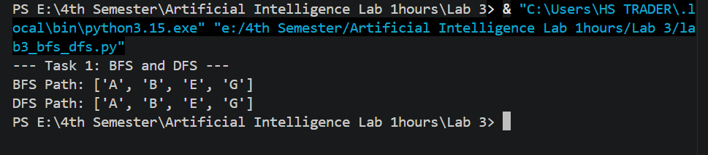
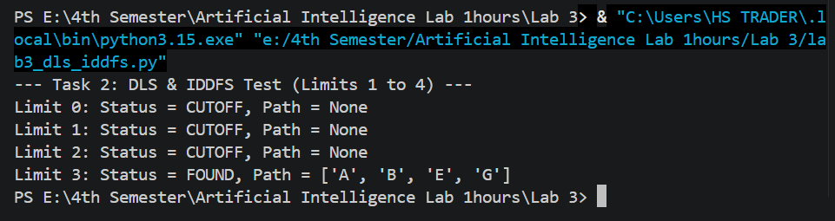
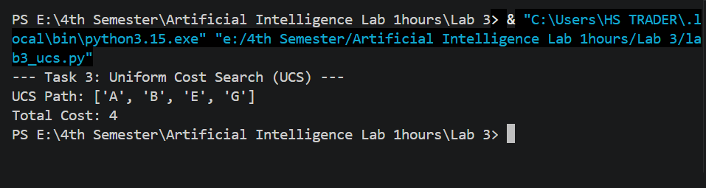
7. Reflection & Conclusion
- Key Learnings: Uninformed search algorithms rely purely on state connectivity. BFS guarantees shortest path by depth, DFS conserves memory, IDDFS combines the optimality/completeness of BFS with the low memory footprint of DFS, and UCS ensures minimum path cost.
- Real-World Application: Rescue robots or navigation systems use UCS when path cost (fuel, distance, safety) varies per road segment rather than simple hop count.

